
SUPPORTLYTICS
Data-Driven Optimization of IT Support Team Performance
Milestone Documentation – Modules 1 to 4

Project | Supportlytics – IT Support Ticket Analytics
Milestone | Modules 1–4
Modules Covered | Project Initialization, Data Cleaning & Feature Engineering, EDA, Business Clustering & Similarity Analysis
Data Source | customer_support_tickets_200k.csv
Prepared By | N Sai Srimannarayana
Status | Completed

Supportlytics: Data-Driven Optimization of ITS Support Team Performance

Milestone 1 (Week 1–2) — Project Initialization, Dataset Setup, Data Cleaning & Feature Engineering

Field | Details
Project | Supportlytics — IT Support Ticket Analytics
Milestone | Milestone 1: Week 1–2
Modules Covered | Module 1 (Project Initialization & Dataset Setup), Module 2 (Data Cleaning & Feature Engineering)
Data Source | Internal IT Support Ticket System (customer_support_tickets_200k.csv)
Prepared By | N Sai Srimannarayana
Status | Complete

Module 1 — Project Initialization and Dataset Setup
1.1 Objective:
The objective of this project is to analyze IT support ticket data to identify key performance trends, optimize resolution times, and enhance service efficiency through data analysis and visualization. The goal is to uncover patterns in customer requests, technical issues, and support performance metrics to recommend improvements in workflow and resource allocation.
1.2 Key Performance Indicators (KPIs):
KPI | Definition | Business Relevance
1. Average Resolution Time (ART) | Mean time (hours/days) between ticket creation and ticket resolution. | Measures operational efficiency and how quickly support teams resolve customer issues.
2. First Response Time (FRT) | Mean time taken to provide the first response after a ticket is created. | Indicates responsiveness and compliance with Service Level Agreements (SLAs).
3. SLA Breach Rate | Percentage of tickets that were not resolved within the defined SLA. | Reflects service reliability and highlights areas where support performance needs improvement.
4. Escalation Rate | Percentage of tickets escalated from first-line support to higher support levels. | Measures triage effectiveness and identifies whether frontline teams can resolve issues independently.
5. Customer Satisfaction (CSAT) | Average customer satisfaction score received after ticket resolution. | Evaluates customer perception of service quality and overall support experience.
6. Ticket Volume by Priority/Category | Number and percentage of tickets grouped by priority level or issue category. | Identifies workload distribution, recurring problem areas, and resource allocation needs.
7. Open / Backlog Rate | Percentage of tickets currently in Open or Pending Customer status. | Helps monitor backlog, workload pressure, and staffing requirements.
8. Repeat Contact Rate | Average number of previous tickets per customer or percentage of customers who submitted multiple tickets. | Reveals recurring customer issues, product quality problems, and customer effort.
9. Issue Complexity Index | Average issue complexity score across all tickets or within each category. | Estimates the effort, expertise, and time required to resolve different issue types.
10. Cluster / Similarity Concentration | Percentage of tickets belonging to the most common issue clusters identified through text analysis or clustering. | Detects high-frequency systemic problems and opportunities for automation or root cause analysis.

1.3 Analytical Workflow
1. Data Acquisition & Understanding— load data, inspect schema, assess quality *(Module 1)*
2. Data Cleaning & Feature Engineering— handle gaps, derive metrics *(Module 2)*
3. Exploratory Data Analysis— volume, priority, category trends *(Module 3)*
4. Clustering & Similarity Analysis — group related issues *(Module 4)*
5. Performance Insights & Optimization — cross-cut performance comparisons *(Module 5)*
6. Visualization & Dashboard Development — charts and dashboard *(Module 6–7)*
7. Final Report & Presentation — consolidated business deliverable *(Module 8)*
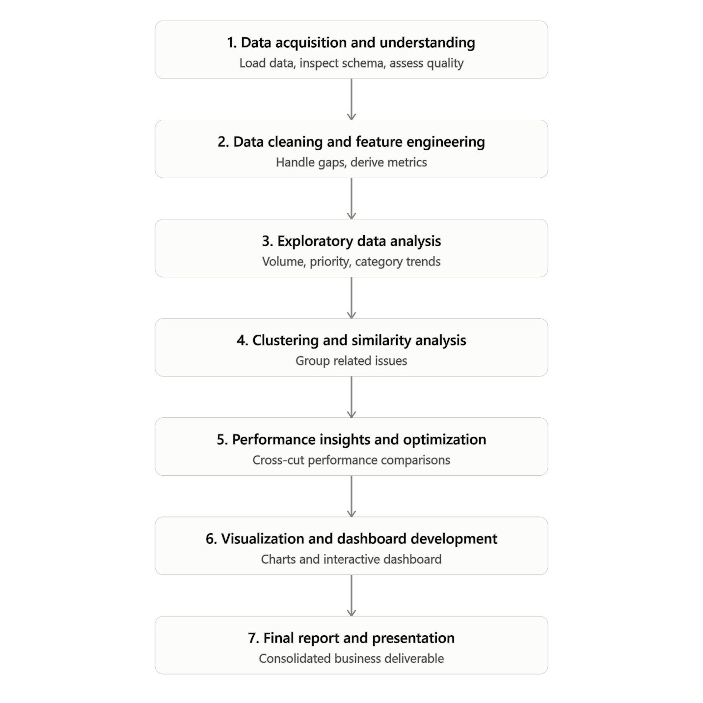
1.4 Environment Setup:
# Core libraries for data acquisition, profiling, and feature engineering
import pandas as pd
import numpy as np
pd.set_option("display.max_columns", None)
pd.set_option("display.width", 150)
RAW_FILE = "customer_support_tickets_200k.csv"
CLEANED_FILE = "customer_support_tickets_200k_cleaned.csv"

"These two settings just configure how pandas prints DataFrames in the notebook — they don't affect the actual data. max_columns=None ensures all 30 columns are visible instead of being truncated, and display.width=150 widens the display so those columns render cleanly on screen instead of wrapping awkwardly. It's a readability setting for exploration, not a data transformation."

1.5 Data Acquisition:
Data Acquisition is simply the first step of any data project: identifying, evaluating, and obtaining the raw dataset you'll actually work with — before any cleaning or analysis happens. It answers three questions: where does the data come from, is it fit for the task, and which version do we commit to?
Since you evaluated three candidate datasets before finalizing customer_support_tickets_200k.csv by madam
Candidate Dataset | Rows (Approx.) | Decision | Reason
synthetic_it_support_tickets.csv | 10000 | Rejected | Synthetic type
Technical Support Dataset.csv | 2023 | Rejected | Sample size too small for reliable clustering, trend analysis, and KPI generation.
customer_support_tickets_200k.csv | 200,000 | Selected — Final | Largest dataset with the richest schema (30 fields). Provides the best coverage of priority, category, status, resolution, SLA, and other fields required for KPI analysis and dashboard development.

Finalized Source: customer_support_tickets_200k.csv
Source Platform: Kaggle
Source URL / Reference: https://www.kaggle.com/datasets/mirzayasirabdullah07/customer-support-tickets-dataset-200k-records
Justification for selection: Provides the largest sample size (200,000 tickets) and the most complete feature set for measuring resolution time, SLA compliance, escalation behavior, and customer segmentation
1.6 Schema and Data Type Exploration
A structural review of the dataset — column names, data types, and cardinality — informs the cleaning and feature engineering plan below.
df.info(), df.describe()
1.7 Data Quality Assessment — Missing Values
The dataset was evaluated for missing values to assess its overall quality before preprocessing. Out of all the features, only one column contained missing values, with 4,0023 null records, representing approximately 20.01% of the total 200,000 records. Since the percentage of missing values was low and limited to a single attribute, it was considered manageable and was handled during the data cleaning phase using an appropriate imputation technique, ensuring minimal impact on subsequent analysis and model development.
Df.isnull().sum()/len(df) * 100
1.8 Initial Ticket Distribution

Baseline view of ticket volume across Priority, Category, Status, and Product.

> Data note: The project brief references a generic "Type" field (Request / Problem /
> Incident). The current extract does not include this classification; `category` and `product`
> serve as the closest available proxies.
1.9 Module 1 — Summary of Findings

(Populated from executed outputs above — see printed statistics.)

Dataset volume, field count, and completeness are confirmed above.
The only column with missing data is `browser`; this is addressed in Module 2.
Ticket volume is well distributed across priority and category, sufficient for downstream
clustering and trend work in Modules 3–4.
ticket_created_date` / `ticket_resolved_date` are stored as text and require conversion to
support duration-based metrics — handled in Module 2 below.
Module 2 — Data Cleaning and Feature Engineering

2.1 Objective
During this operational phase, we systematically addressed core data quality anomalies within the customer support ticket ecosystem and engineered strategic analytical dimensions. These enhancements establish a reliable foundation for granular resolution-time analytics, SLA tracking, and downstream machine learning modules (such as customer clustering and predictive routing).
2.2 Cleaning & Engineering Plan
Step | Action | Rationale
1 | Convert ticket_created_date and ticket_resolved_date to datetime | Required for date arithmetic and duration calculations.
2 | Derive Resolution_Duration_Days = ticket_resolved_date - ticket_created_date | Creates a standardized feature for resolution-time analysis.
3 | Impute missing browser values using the mode within each operating_system group | Preserves relationships between browser and operating system while handling missing values more accurately than a global mode.
4 | Derive Priority_Score (Urgent = 4, High = 3, Medium = 2, Low = 1) | Converts priority into a numerical feature for weighted performance analysis and machine learning.
5 | Flag logical inconsistencies (e.g., ticket_resolved_date < ticket_created_date) | Ensures data integrity by identifying invalid records before analysis.
6 | Save the cleaned dataset and prepare a data dictionary | Provides a reusable dataset for downstream EDA, visualization, and machine learning modules.

2.3 Save Cleaned Dataset and Deliverables

To ensure compliance with enterprise source control policies and platform file-size restrictions (>25 MB), all verified data products have been bundled into a secure deployment artifact: deliverables.zip.
Cleaned Production Dataset (customer_support_tickets_cleaned.csv)
- The single source of truth containing all original structural data points across 200,000 records, enriched with our newly engineered operational tracking vectors.
Data Dictionary Schema (data_dictionary.csv)
- A complete reference catalog mapping dataset attributes, strict data types, unique cardinality metrics, missing record indices, and explicit column descriptions.
Feature Engineering Audit Trail (feature_engineering_summary.txt)
- A structured plain-text manifest file summarizing our transformation rules, business-logic mapping tables, and validation checkpoints for compliance auditing.
Milestone 2 (Week 3–4)
Modules: Exploratory Data Analysis (Module 3) & Business Clustering and Similarity Analysis (Module 4)
Field | Details
Project | Supportlytics – IT Support Ticket Analytics
Milestone | Milestone 2 (Week 3–4)
Modules Covered | Module 3 (EDA), Module 4 (Business Clustering & Similarity Analysis)
Dataset | customer_support_tickets_200k_cleaned.csv
Prepared By | N Sai Srimannarayana
Status | Completed

Module 3 — Exploratory Data Analysis (EDA)

3.1 Objective
This module analyzes ticket distributions across Type, Category, Priority, and operational Queue to understand workload patterns, service demand, and business trends. The analysis establishes the foundation for clustering, performance optimization, and dashboard development.

3.2 Business Objectives
Business Question | Purpose
Which ticket types occur most frequently? | Understand workload distribution
Which categories generate the highest volume? | Identify recurring issues
Which priorities dominate? | Analyze operational urgency
Which queues receive the maximum tickets? | Measure team workload

3.3 Queue Mapping Strategy
Issue categories were mapped into operational queues to reflect business ownership and routing.
Category | Assigned Queue
Login Issue | Technical Support
Account Suspension | Account Management
Payment Problem | Billing Support
Refund Request | Billing Support
Security Concern | Security Team
Bug Report | Development Team
Performance Issue | Infrastructure Team
Data Sync Issue | Infrastructure Team
Subscription Cancellation | Account Management
Feature Request | Product Team

3.4 Visualizations
• Ticket Distribution by Type – Shows workload by ticket type.
• Top Categories by Frequency – Identifies recurring issue categories.
• Ticket Distribution by Priority – Measures urgency distribution.
• Ticket Volume by Queue – Compares operational queue workloads.

Module 4 — Business Clustering & Similarity Analysis

4.1 Objective
Business-informed clustering combines TF-IDF text vectorization with predefined business mappings to group related support tickets and compute similarity scores.

4.2 TF-IDF Configuration
Parameter | Value
Maximum Features | 300
Stop Words | English
Minimum Document Frequency | 5

4.3 Business Cluster Mapping
Category | Cluster
Login Issue | Security & Access
Security Concern | Security & Access
Account Suspension | Account & Subscription
Subscription Cancellation | Account & Subscription
Payment Problem | Billing & Refunds
Refund Request | Billing & Refunds
Performance Issue | Performance & Data
Data Sync Issue | Performance & Data
Bug Report | System Bugs
Feature Request | Feature Requests

4.4 Generated Outputs
- Cluster_Name
- Cluster_ID
- Similarity_Score
- Eight analytical visualizations
- customer_support_tickets_200k_with_clusters.csv

4.5 Summary
The module successfully transformed issue descriptions into business-oriented clusters using TF-IDF and cosine similarity. The generated insights support intelligent routing, workload analysis, and operational decision-making.

Milestone 3 & Milestone 4 — Performance, Dashboard & Final Documentation
Week 5–8 implementation documentation appended to the retained Milestone 1–2 project document.
Milestone 3 & 4 — Scope and High-Level Requirements
This document consolidates the Week 5–6 and Week 7–8 implementation documentation into one project artifact suitable for version control and GitHub project documentation. It follows the Supportlytics module structure and is aligned with the implemented analytical code and Power BI reporting layer.
Milestone 3: Week 5–6
Milestone 3 extends the analytical foundation created in Modules 1–4 into performance trend analysis and geographic/category-level insight generation.
Module | Purpose | High-Level Requirements
Module 5 – Performance Trend Analysis | Measure operational resolution performance and identify priority/backlog areas. | Analyze average resolution times by priority and type; determine which regions or teams handle tickets fastest; identify high-priority unresolved issues.
Module 6 – Geographic and Category-Level Insights | Extend analysis into regional concentration, geographic representation and performance relationships. | Create heatmaps of ticket concentration by region; map issue categories geographically using latitude/longitude or documented regional coordinates; evaluate cluster size versus performance score; prepare performance and comparative visualizations.
Milestone 4: Week 7–8
Milestone 4 converts the analytical work into a management-facing reporting layer and formal project documentation package.
Module | Purpose | High-Level Requirements
Module 7 – Dashboard/Report Preparation | Combine analytical visuals into an interactive reporting experience. | Combine visual insights into an interactive Power BI or Streamlit dashboard; organize visualizations around Average Resolution Time, Most Frequent Categories, Cluster Similarity Index and Top Performing Regions.
Module 8 – Documentation and Presentation | Finalize project communication, handover and version-controlled deliverables. | Finalize project report (PDF/README); prepare presentation slides highlighting insights and recommendations; upload code, visuals and report to GitHub.

Module 5 — Performance Trend Analysis
Milestone 3 • Week 5–6
5.1 Objective
The objective of Module 5 is to analyze operational performance across priority, ticket type, region and team. The module extends the KPI framework established in earlier milestones by focusing on resolution speed and unresolved high-priority workload.
5.2 Requirements
- Analyze average resolution times by priority and type.
- Determine which regions or teams handle tickets fastest.
- Identify high-priority unresolved issues.
5.3 Resolution Time by Priority and Type
Average resolution time is grouped by priority and the business Type classification established earlier in the project. The analysis uses the resolution_time_hours field and supports comparison across Request, Problem and Incident categories.
- Group resolution_time_hours by priority.
- Group resolution_time_hours by Type.
- Create a priority-versus-Type comparison for operational interpretation.
- Use consistent resolution-time units across the analytical workflow.
5.4 Region and Team Performance
Regional and team-level resolution analysis is used to compare operational handling speed. Team classification is derived from the business-informed cluster structure so that team-level performance remains aligned with the project's issue taxonomy.
- Calculate average resolution time by region.
- Calculate average resolution time by Team.
- Compare relative operational handling speed.
- Use the same performance definition across region and team views.
5.5 High-Priority Unresolved Issues
The unresolved high-priority analysis isolates tickets where priority is High or Urgent and the ticket is not in a fully resolved state. This creates a focused backlog-risk view for operational management.
- Filter High and Urgent priority tickets.
- Exclude Closed and Resolved states from the unresolved population.
- Group the remaining tickets by status for operational review.
- Use the resulting population as an input to backlog and dashboard analysis.
5.6 Analytical Implementation Reference
# Average resolution time by priority and Type
resolution_by_priority_type = (
df.groupby(["priority", "Type"])["resolution_time_hours"]
.mean()
.reset_index()
)
# High-priority unresolved tickets
high_priority_unresolved = df[
df["priority"].isin(["High", "Urgent"]) &
~df["status"].isin(["Closed", "Resolved"])
]
5.7 Module 5 Deliverables
- Performance metrics summary.
- Priority and Type resolution-time analysis.
- Region and Team comparison.
- High-priority unresolved issue analysis.
- Comparative charts for operational performance.

Module 6 — Geographic and Category-Level Insights
Milestone 3 • Week 5–6
6.1 Objective
The objective of Module 6 is to analyze the geographic distribution of support demand, examine category concentration across regions and evaluate the relationship between business issue-cluster size and the composite performance score.
6.2 Requirements
- Create heatmaps of ticket concentration by region.
- Map issue categories geographically using latitude/longitude.
- Evaluate the relationship between cluster size and performance score.
- Prepare geographic visualizations and comparative charts.
6.3 Ticket Concentration by Region
Ticket concentration is analyzed using region and category dimensions. A region-by-category matrix is used to support heatmap visualization and identify where particular support issue categories are concentrated.
- Group tickets by region and category.
- Create a region × category concentration matrix.
- Visualize the matrix as a heatmap.
- Compare regional ticket volume using the same regional dimension.
6.4 Geographic Mapping of Issue Categories
The source dataset does not contain customer-level latitude and longitude. The implemented geographic visualization therefore uses documented regional geographic centroids to provide a consistent geographic reference for the six region values. This is a regional representation and should not be interpreted as customer-level geolocation.
- Maintain a documented region-to-coordinate mapping.
- Validate that each region in the dataset is represented in the mapping.
- Assign approximate latitude and longitude fields for visualization.
- Add controlled jitter to sampled points when necessary to improve map readability.
- Color or group the visualization by issue category.
6.5 Cluster Size versus Performance Score
Module 6 evaluates whether issue-cluster size is associated with operational performance. Performance_Score is constructed from normalized resolution speed, customer satisfaction and SLA compliance.
- Normalize resolution speed into a performance-oriented score.
- Normalize customer satisfaction to a 0–100 scale.
- Convert SLA compliance into a binary performance component.
- Combine the components using the implemented weighting.
- Aggregate ticket count and average Performance_Score by Cluster_Name.
- Compare cluster size with average performance using a scatter plot and correlation measure.
6.6 Analytical Implementation Reference
# Geographic representation
region_centroids = {
# documented regional centroid coordinates
}
df["approx_latitude"] = df["region"].map(
lambda x: region_centroids.get(x, (np.nan, np.nan))[0]
)
df["approx_longitude"] = df["region"].map(
lambda x: region_centroids.get(x, (np.nan, np.nan))[1]
)
# Composite performance score
speed_score = 100 * (
1 - (df["resolution_time_hours"] - res_min) /
(res_max - res_min)
)
satisfaction_score = (
(df["customer_satisfaction_score"] - 1) / 4 * 100
)
sla_score = np.where(df["sla_breached"] == "No", 100, 0)
df["Performance_Score"] = (
speed_score * 0.4 +
satisfaction_score * 0.4 +
sla_score * 0.2
).round(2)
6.7 Module 6 Deliverables
- Performance metrics summary.
- Region × Category heatmap.
- Regional ticket-volume visualization.
- Geographic issue-category visualization.
- Cluster size versus Performance_Score comparison.
- Comparative charts supporting management interpretation.

Module 7 — Dashboard / Report Preparation
Milestone 4 • Week 7–8
7.1 Objective
The objective of Module 7 is to consolidate the analytical work from Modules 1–6 into an interactive Power BI or Streamlit reporting experience. The dashboard is designed to move from executive-level KPI monitoring to operational drill-down.
7.2 Requirements
- Combine visual insights into an interactive Power BI or Streamlit dashboard.
- Organize visualizations into performance KPIs.
- Include Average Resolution Time.
- Include Most Frequent Categories.
- Include Cluster Similarity Index.
- Include Top Performing Regions.
7.3 Final Power BI Information Architecture
Dashboard Page | Purpose | Analytical Focus
Overview | Executive support monitoring | Core KPIs, workload, category trends, region performance, priority/type mix, queue volume and cluster frequency
Introduction | Project and KPI context | Definitions, date filtering and operational measures
Region Insights | Regional performance analysis | Regional workload, resolution behavior, map and regional trends
Cluster Analysis | Business issue-family analysis | Cluster frequency, cluster size, similarity distribution and category detail
Category Trends | Category-level analysis | Resolution, CSAT, SLA and escalation dimensions
Priority & Type | Urgency and ticket classification | Priority and Request/Problem/Incident analysis
Team & Queue | Operational ownership analysis | Team and queue workload, resolution and SLA views
7.4 Dashboard Design Principles
- Maintain consistent KPI definitions across pages.
- Provide date-based filtering for period analysis.
- Provide Team and operational-dimension filtering where applicable.
- Maintain a clear executive-to-operational drill-down structure.
- Use the same business terminology as the analytical data model.
- Separate executive monitoring from detailed diagnostic analysis.
7.5 Data Model Dependency
The dashboard consumes the analytical fields created during the preceding modules, including Type, Queue, Priority_Score, Resolution_Duration_Days, Cluster_Name, Cluster_ID, Similarity_Score and Performance_Score.
7.6 Dashboard Validation Checklist
Verify ticket-volume KPIs use count-based aggregation.
Validate date slicer behavior across KPI cards and visuals.
Validate SLA measure definitions and percentage formatting.
Validate Team and Queue mappings against the documented business ownership.
Label geographic visuals according to the available geographic precision.
Verify that dashboard filters affect the intended visuals.
Document the dashboard refresh and publication process.
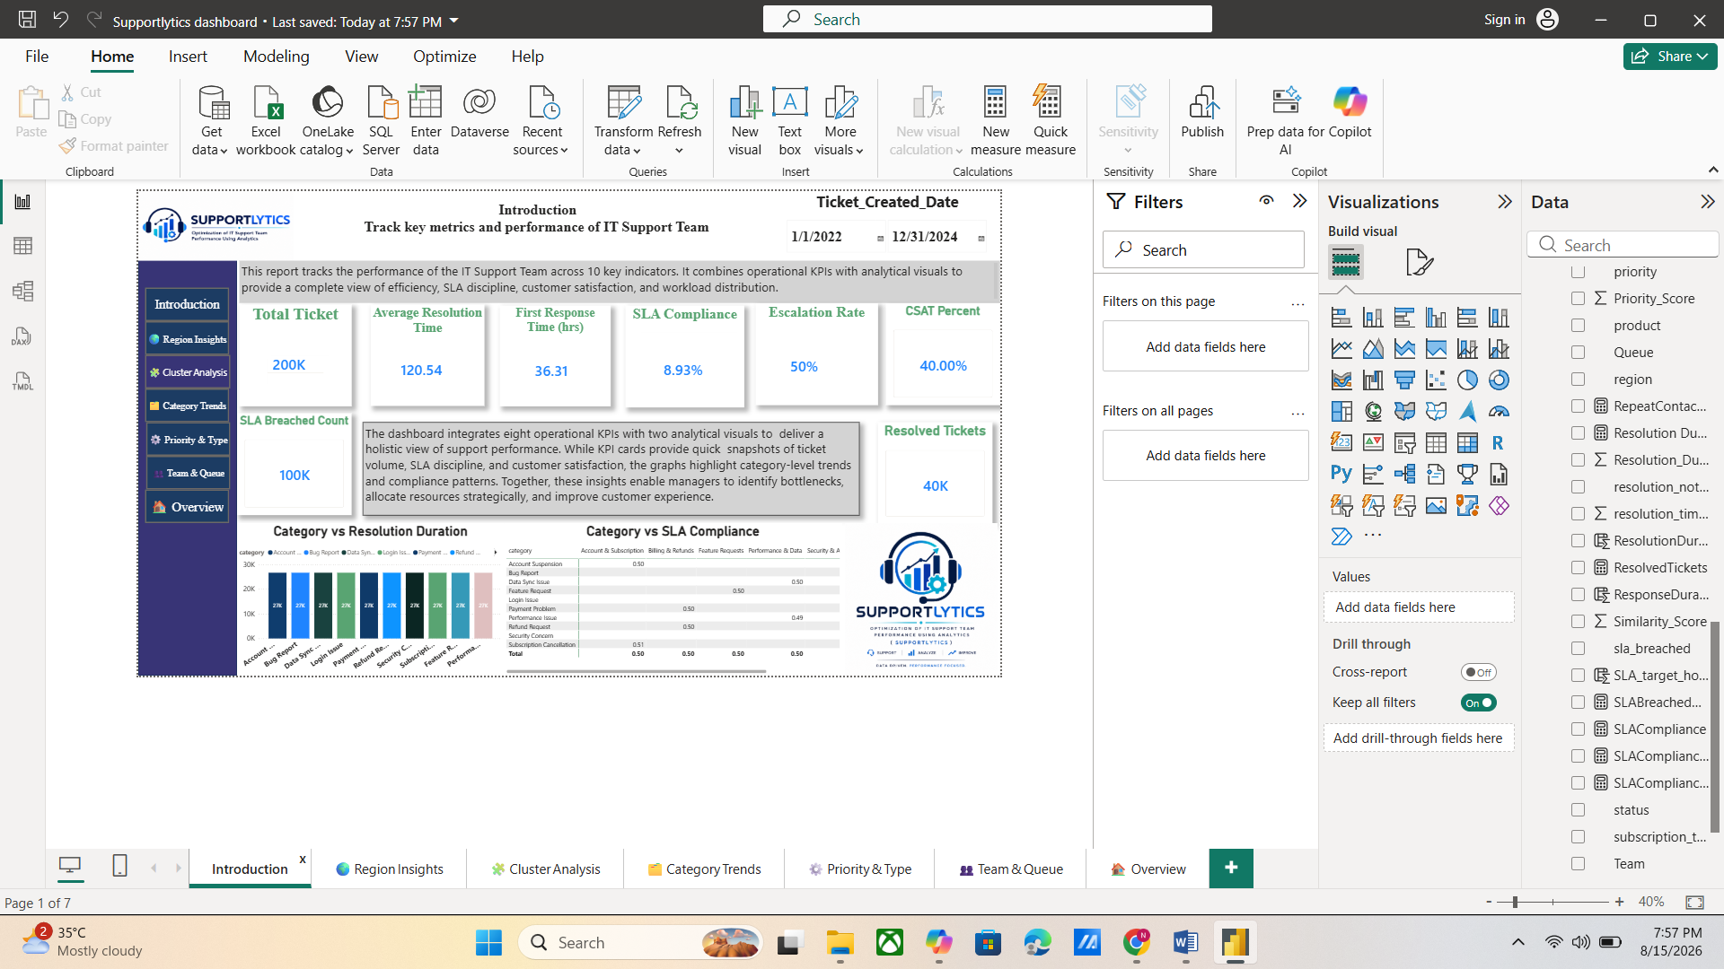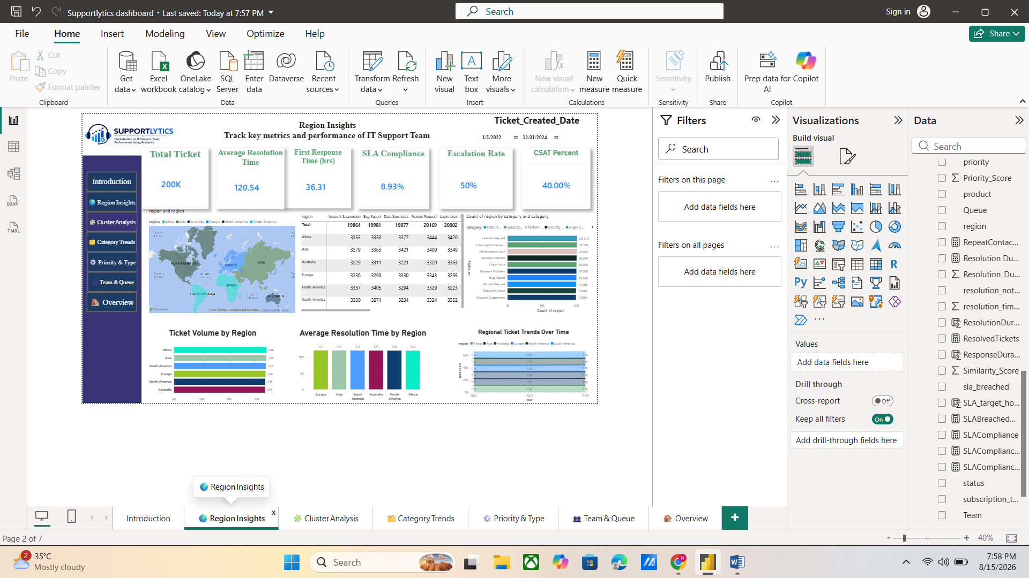
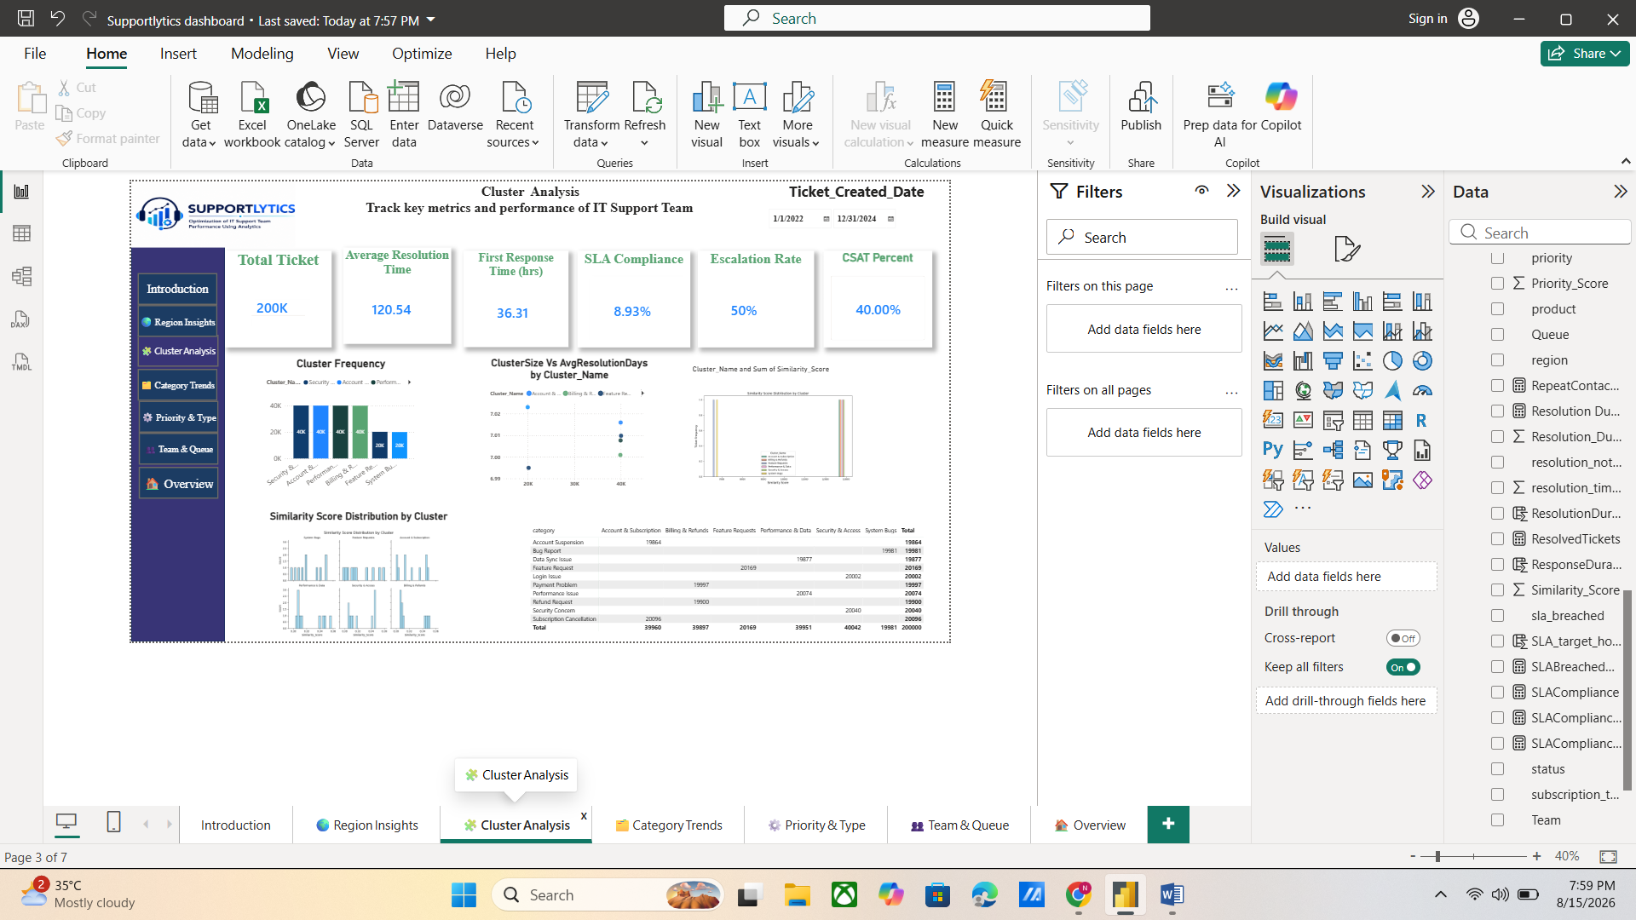
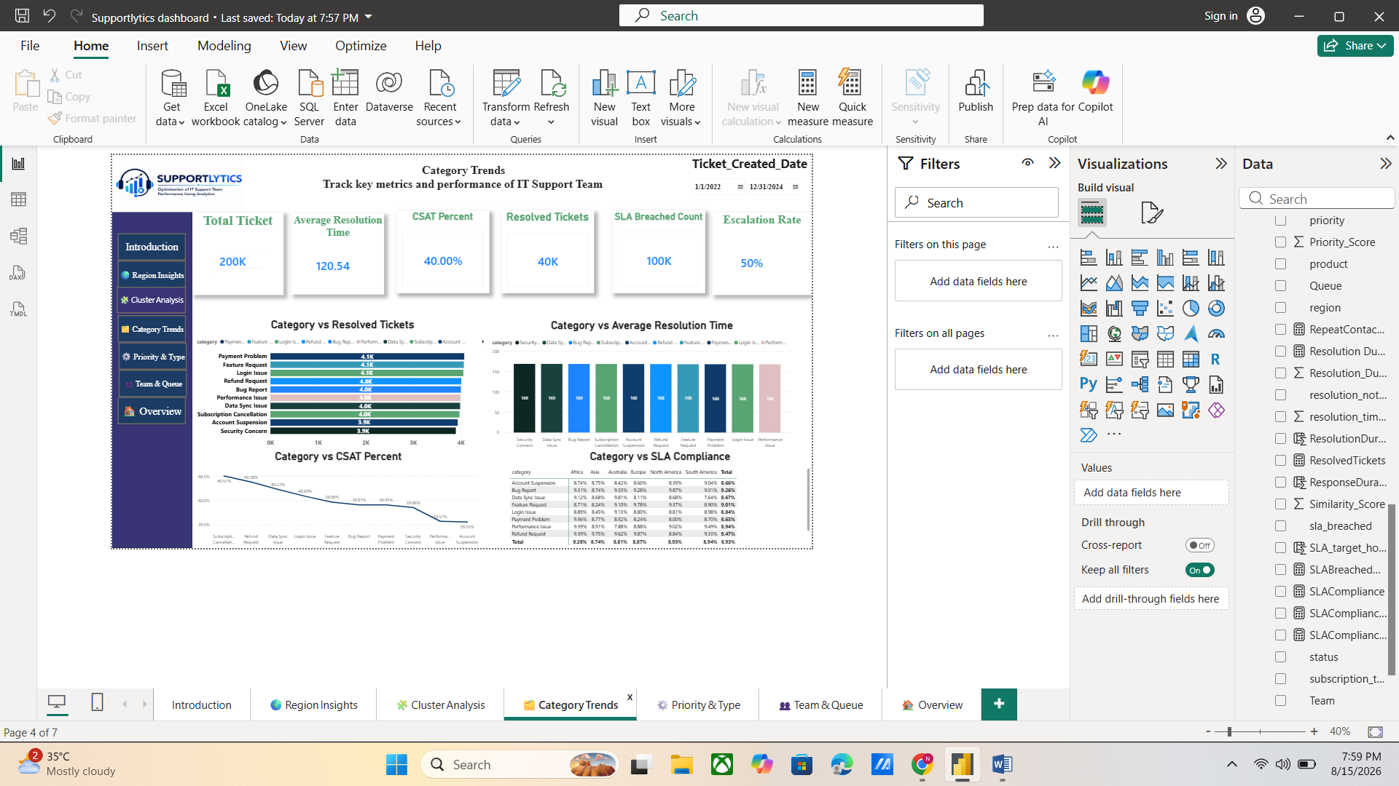
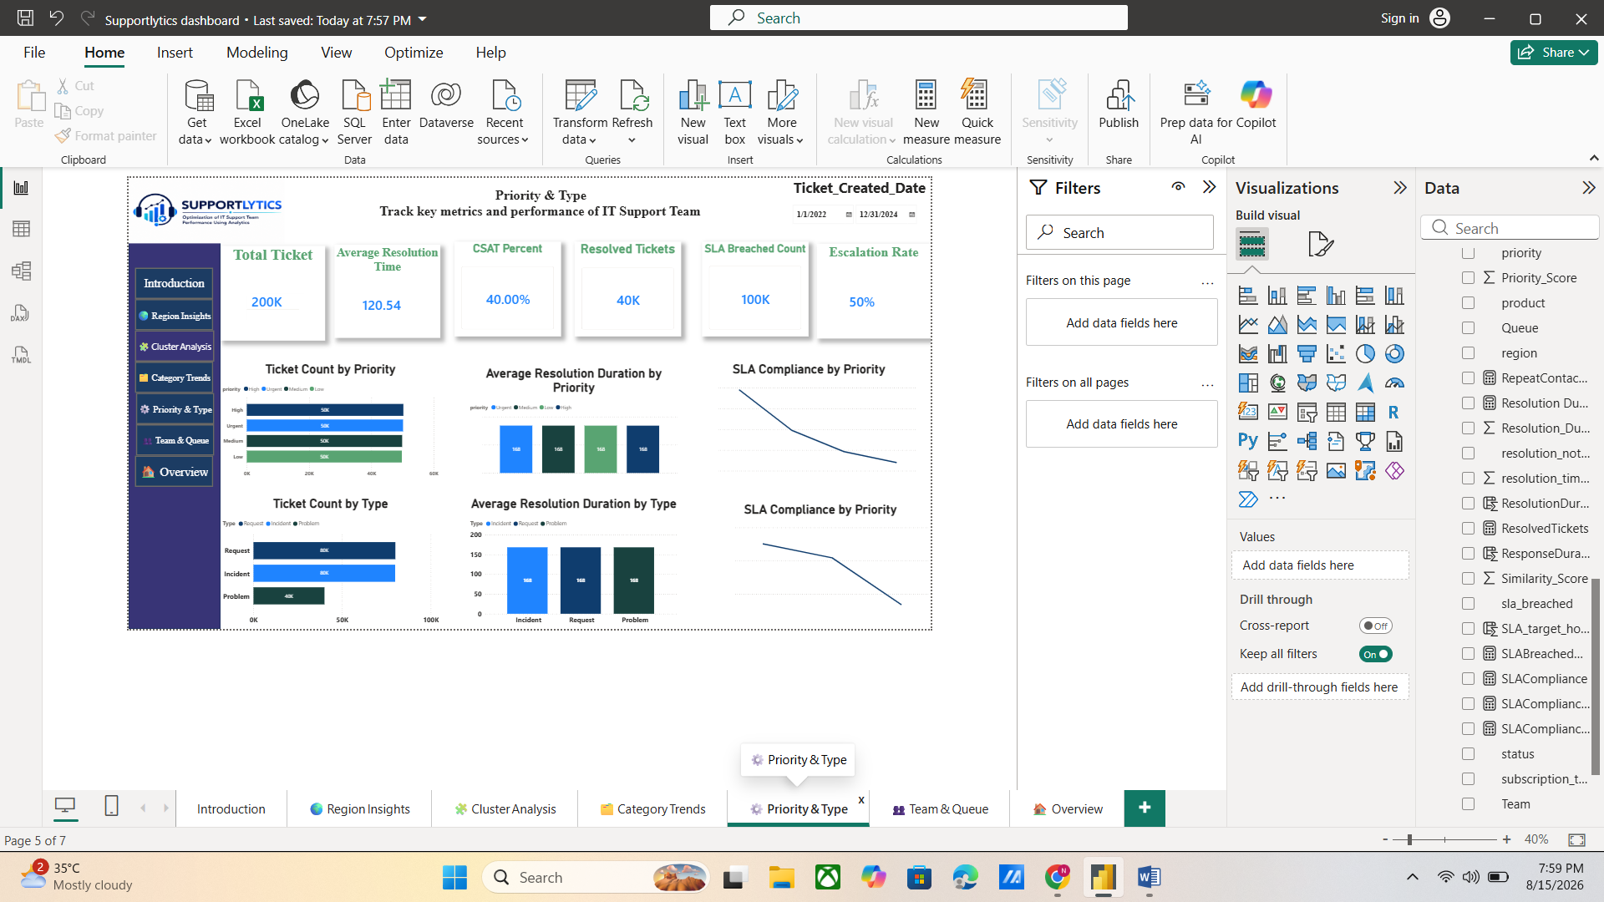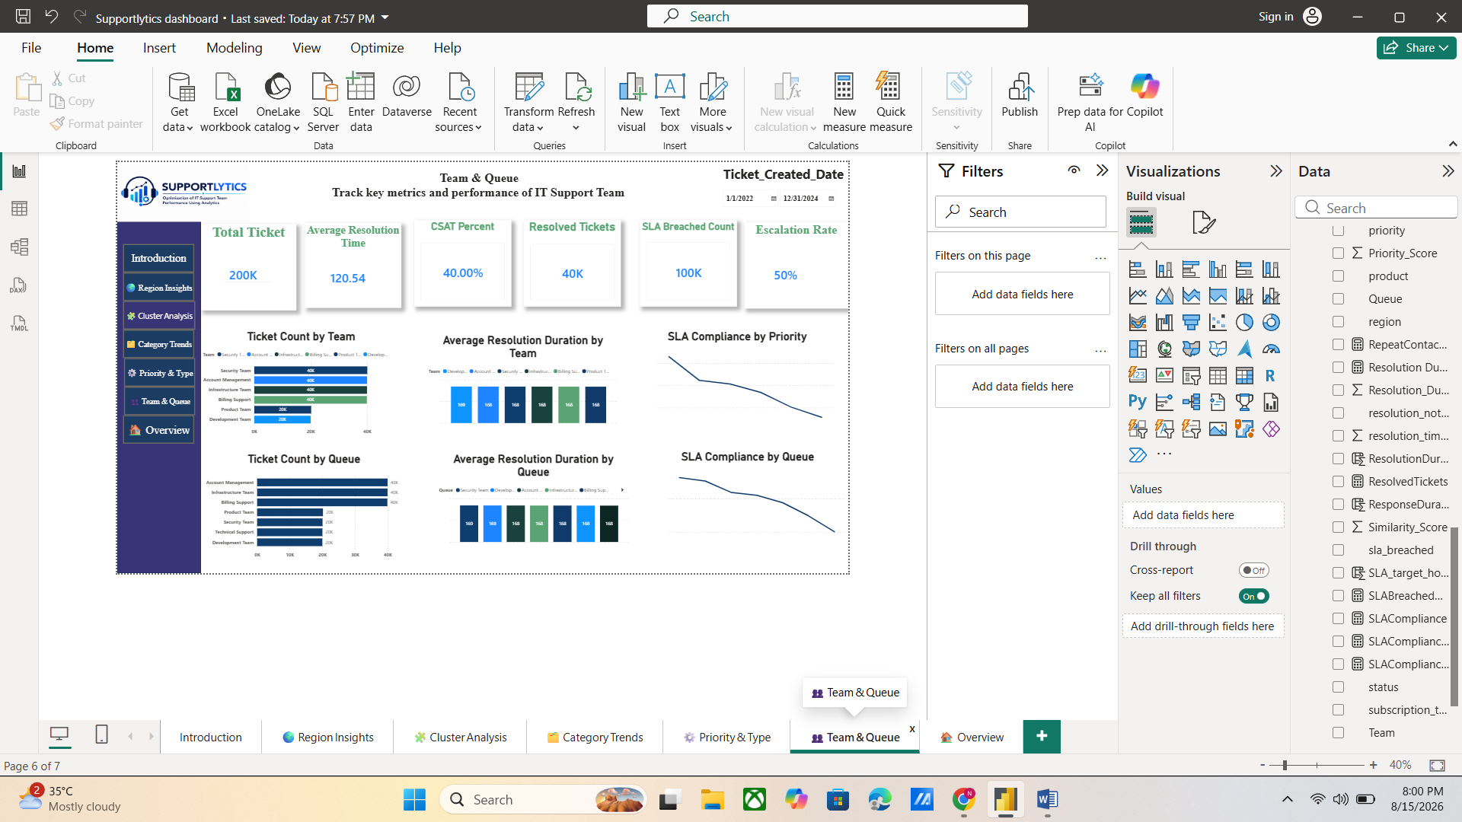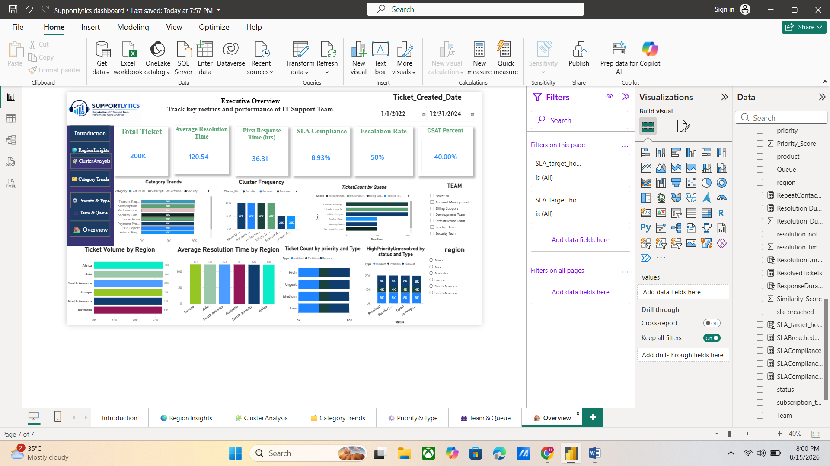

Conclusion
The Supportlytics project successfully established a complete analytics-driven framework for evaluating and improving IT support team performance. The project progressed through data acquisition, data cleaning, feature engineering, exploratory analysis, business-informed clustering, similarity analysis, performance analysis, geographic insights, dashboard development, and final documentation.
Across the completed milestones, the project transformed raw IT support ticket data into a structured analytical solution capable of supporting operational decision-making. The implementation provides a consistent approach for analyzing ticket workload, resolution performance, SLA behavior, customer satisfaction, escalation patterns, issue clusters, regional performance, and team-level operations.
The integration of Python-based analytics, NLP similarity analysis, business-informed clustering, and Power BI reporting provides both technical depth and practical business value. The final dashboard brings the major analytical dimensions together into an interactive reporting environment that can be used by stakeholders to monitor performance and identify areas requiring operational attention.
The project demonstrates how support-ticket data can be transformed from basic operational records into meaningful business intelligence. The insights generated through Supportlytics can support improvements in resolution efficiency, SLA management, workload balancing, issue routing, team resource allocation, and customer service quality.
Overall, Supportlytics provides a scalable foundation for data-driven IT support performance management and continuous operational improvement.

